

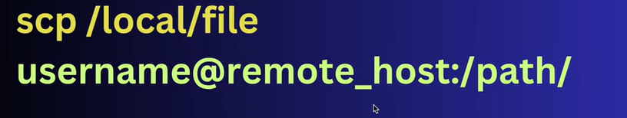



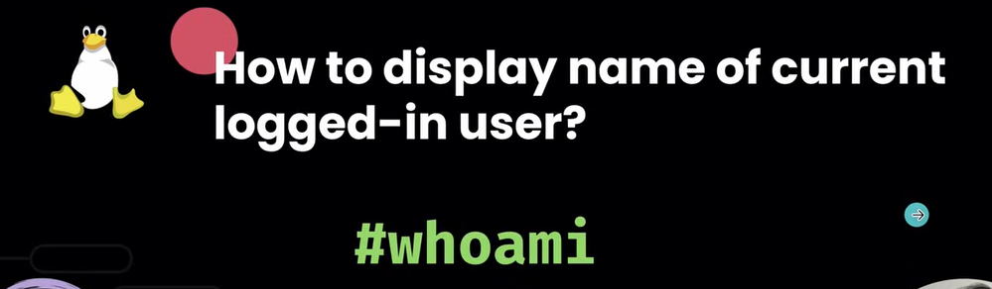



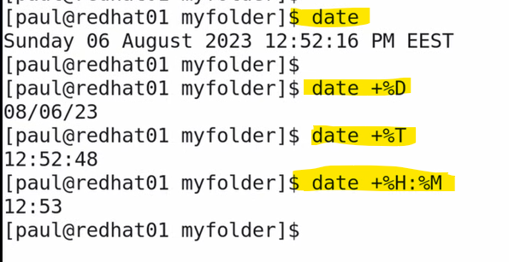





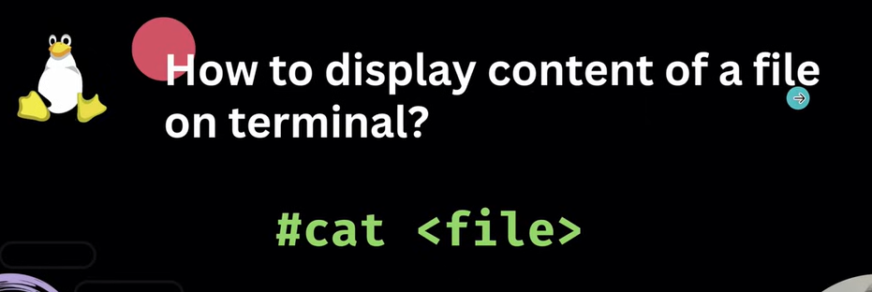



To search for a string, top to bottom, press forward slash (/) followed by a string:

Bottom to Top search: - ?string

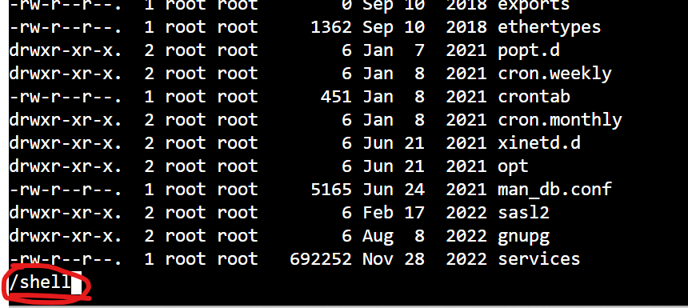

Press “n” for the next occurrence of the string

Shift+g :– go to the last line of the file

p :- go to the first line of the file

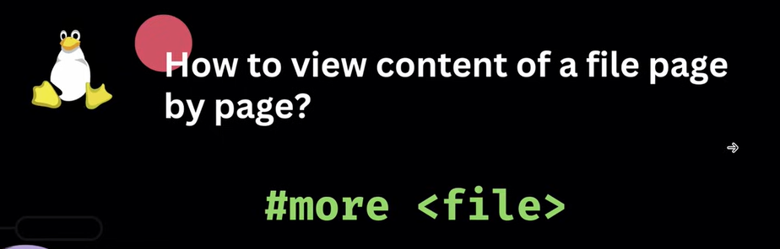





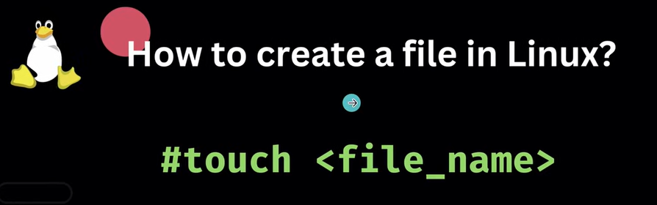

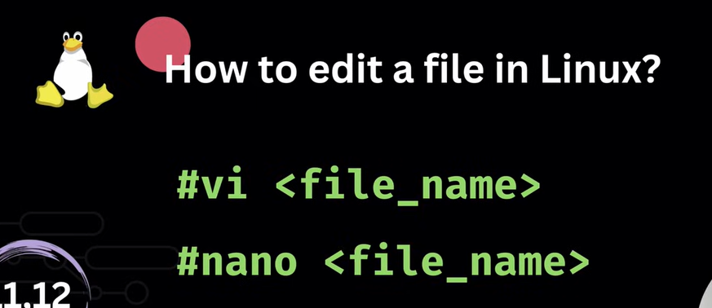

VI Editor options:

**Opening and Exiting Files:**

* vi filename: Opens or creates filename for editing.
* vi +n filename: Opens filename and positions the cursor at line n.
* vi +/pattern filename: Opens filename and positions the cursor at the first line containing pattern.
* :w: Saves the file.
* :q: Quits the editor.
* :wq or ZZ: Saves and quits the editor.
* :q!: Quits without saving changes.

**Navigation (in Command Mode):**

* h, j, k, l: Move the cursor left, down, up, and right, respectively.
* w or b: Move to the beginning of the next or previous word.
* e: Move to the end of the current word.
* 0: Move to the beginning of the current line.
* $: Move to the end of the current line.
* gg: Move to the first line of the file.
* G: Move to the last line of the file.
* nG: Move to line n.
* Ctrl-f: Scroll forward one screen.
* Ctrl-b: Scroll backward one screen.

**Editing (in Command Mode):**

* x: Delete the character under the cursor.
* dw: Delete a word.
* dd: Delete the current line.
* ndd: Delete n lines.
* yy: Copy (yank) the current line.
* nyy: Copy n lines.
* p: Paste content below the current line.
* P: Paste content above the current line.
* u: Undo the last change.
* Ctrl-r: Redo an undone change.

**Entering Insert Mode:**

* i: Insert text before the cursor.
* a: Append text after the cursor.
* o: Open a new line below the current line and enter insert mode.
* O: Open a new line above the current line and enter insert mode.
* I: Insert text at the beginning of the current line.
* A: Append text at the end of the current line.

**Searching:**

* /pattern: Search forward for pattern.
* ?pattern: Search backward for pattern.
* n: Repeat the last search in the same direction.
* N: Repeat the last search in the opposite direction.



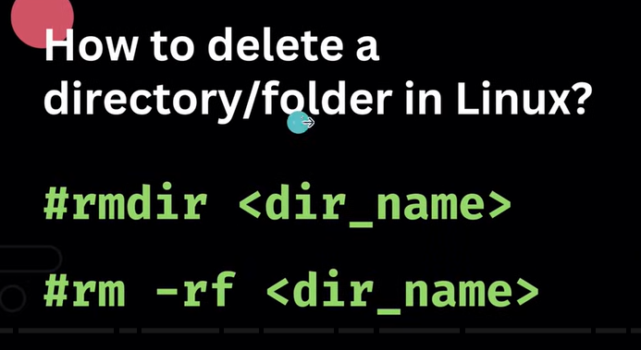

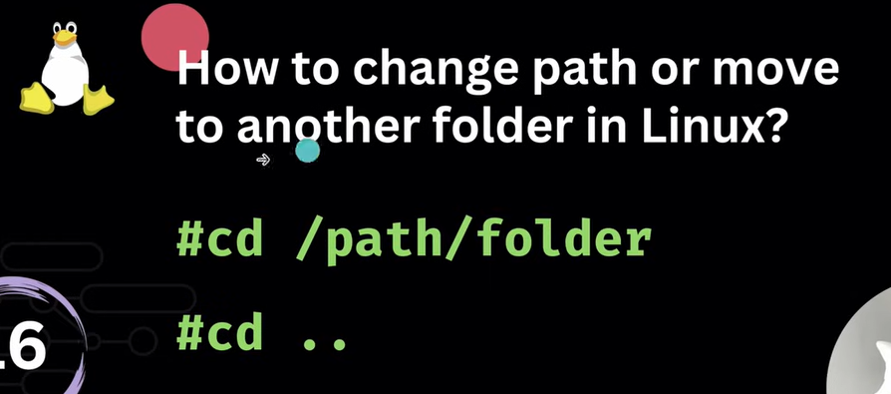

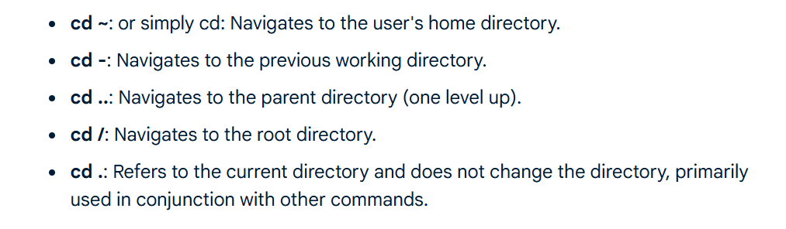





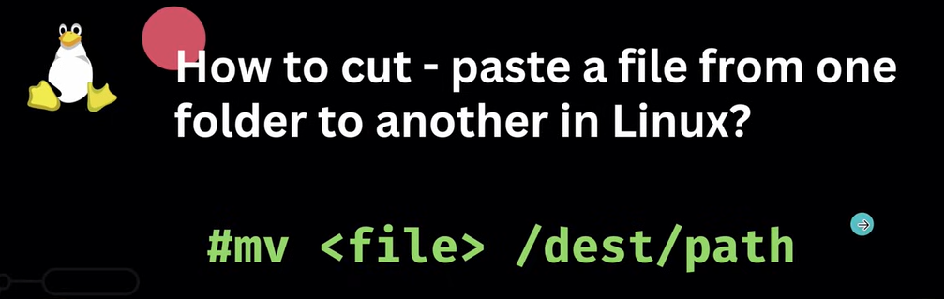







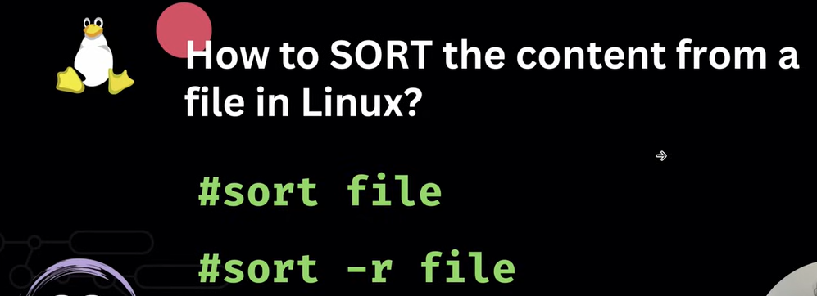



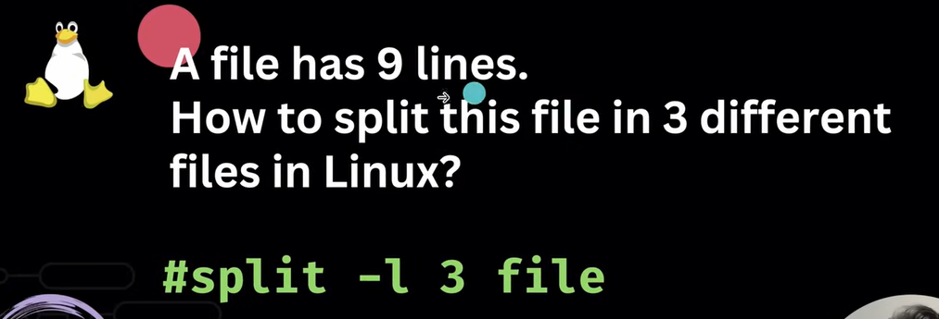



Search Behavior Options:

* **-i, --ignore-case**: Ignores case distinctions in the pattern and input data.
* **-v, --invert-match**: Inverts the match, selecting non-matching lines.
* **-w, --word-regexp**: Selects only those lines containing matches that form whole words.
* **-x, --line-regexp**: Selects only those matches that match the whole line.
* **-E, --extended-regexp**: Interprets PATTERN as an extended regular expression (ERE).
* **-F, --fixed-strings**: Interprets PATTERN as a list of fixed strings, separated by newlines, any of which is to be matched.
* **-r, --recursive**: Reads all files under each directory, recursively.
* **-R, --dereference-recursive**: Similar to -r, but follows symbolic links.

Output Control Options:

* **-n, --line-number**: Prefixes each line of output with the 1-based line number within its input file.
* **-c, --count**: Suppresses normal output; instead, prints a count of matching lines for each input file.
* **-l, --files-with-matches**: Suppresses normal output; instead, prints the name of each input file from which output would normally have been printed.
* **-L, --files-without-matches**: Suppresses normal output; instead, prints the name of each input file from which no output would normally have been printed.
* **-o, --only-matching**: Prints only the matched (non-empty) parts of a matching line, with each such part on a separate output line.
* **-h, --no-filename**: Suppresses the prefixing of output lines with file names when there is more than one file to search.
* **-H, --with-filename**: Prints the filename for each match (default when searching multiple files).
* **-A NUM, --after-context=NUM**: Prints NUM lines of trailing context after matching lines.
* **-B NUM, --before-context=NUM**: Prints NUM lines of leading context before matching lines.
* **-C NUM, --context=NUM**: Prints NUM lines of output context around matching lines (equivalent to -A NUM -B NUM).
* **--color[=WHEN]**: Highlights matches. WHEN can be always, never, or auto.

Other Useful Options:

* **-q, --quiet, --silent**: Suppresses all normal output. grep will exit immediately with status 0 if any match is found, and 1 otherwise.
* **-s, --no-messages**: Suppresses error messages about non-existent or unreadable files.
* **-m NUM, --max-count=NUM**: Stops reading a file after NUM matching lines.
* **-a, --text**: Processes a binary file as if it were text.

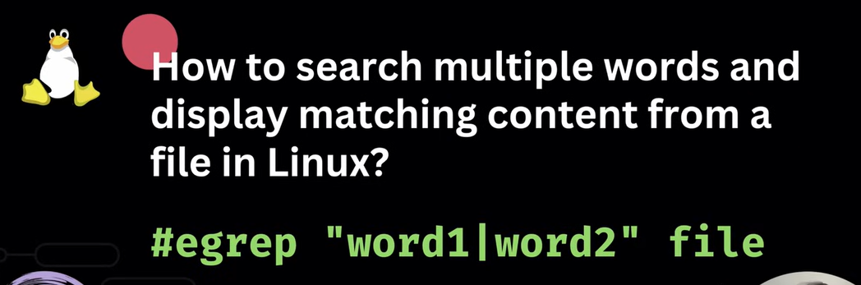

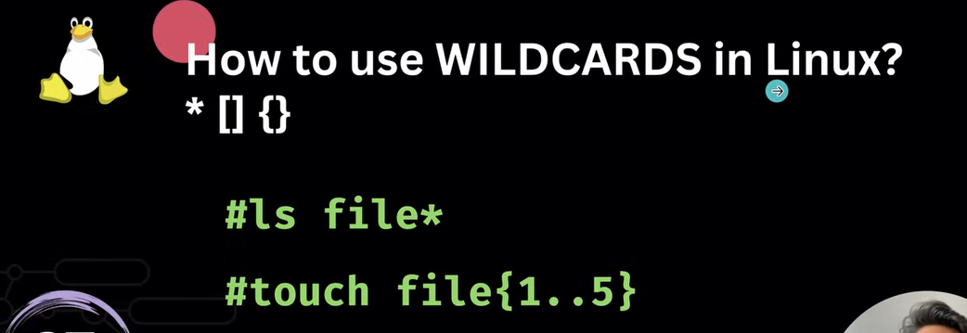

* **Asterisk (*):**

Matches zero or more characters.

* + Example: ls *.txt will list all files ending with .txt.
  + Example: rm doc* will remove all files starting with "doc".
* **Question Mark (?):**

Matches exactly one character.

* + Example: ls file?.log will list files like file1.log, fileA.log, but not file10.log.
* **Square Brackets ([]):**

Matches any single character within the specified set.

* + Example: ls [abc]file.txt will list afile.txt, bfile.txt, or cfile.txt.
  + Example: ls [0-9].log will list files named 0.log, 1.log, up to 9.log.
  + Example: ls [!aeiou]* will list files that do not start with a lowercase vowel.
* **Curly Braces ({}):**

Allows for matching multiple specific strings or patterns.

* + Example: cp file{1,2,3}.txt /backup/ will copy file1.txt, file2.txt, and file3.txt to the /backup/ directory.

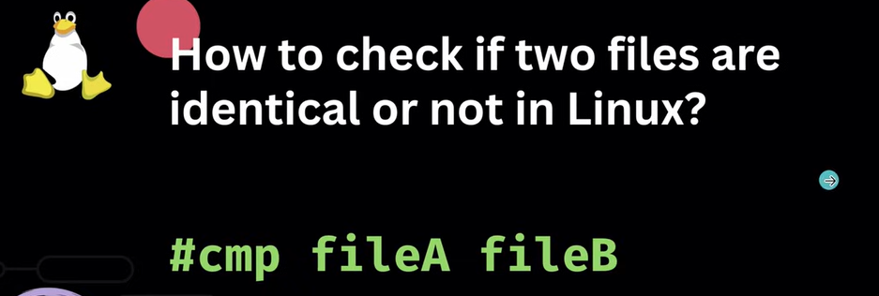



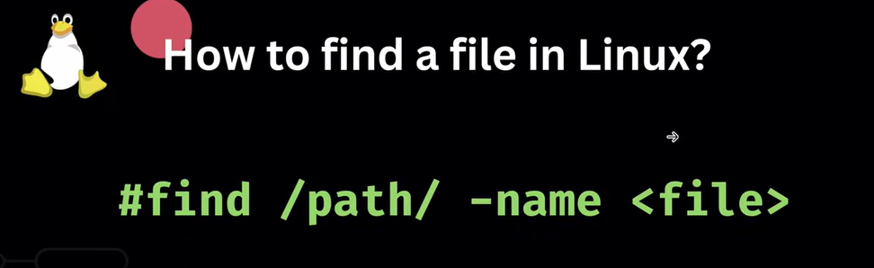

* **-name "pattern"**: Finds files/directories with a name matching the specified pattern (case-sensitive).
* **-iname "pattern"**: Finds files/directories with a name matching the specified pattern (case-insensitive).
* **-type type**: Specifies the type of file to search for. Common types include:
  + f: regular file
  + d: directory
  + l: symbolic link
* **-user username**: Finds files/directories owned by a specific user.
* **-group groupname**: Finds files/directories owned by a specific group.
* **-perm permissions**: Finds files/directories with specific permissions (e.g., 644, 755).
* **-size n[cwbkMG]**: Finds files based on their size. n is an integer, and the suffix specifies units (e.g., c for bytes, k for kilobytes, M for megabytes).
* **-mtime n**: Finds files modified n days ago. +n means more than n days, -n means less than n days, and n means exactly n days.
* **-atime n**: Finds files accessed n days ago.
* **-ctime n**: Finds files whose status (inode data) was changed n days ago.
* **-empty**: Finds empty files or directories.

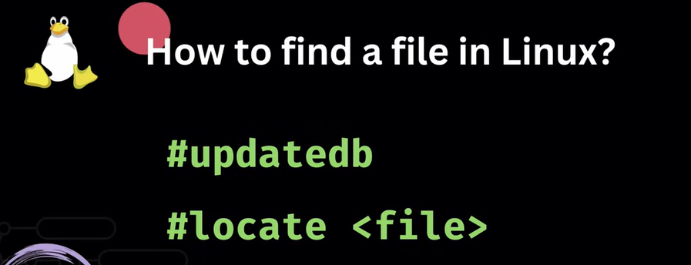







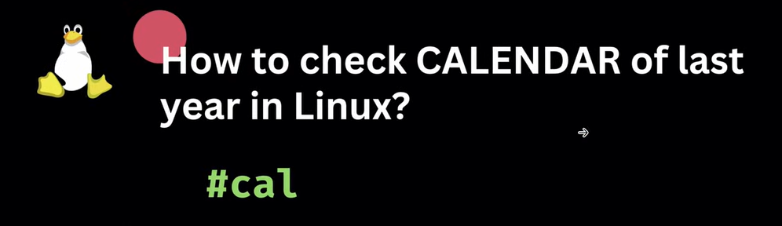





**Press Ctl+d to exit**

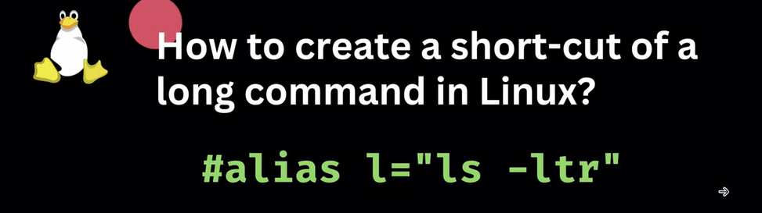

**To check existing alias:  
**



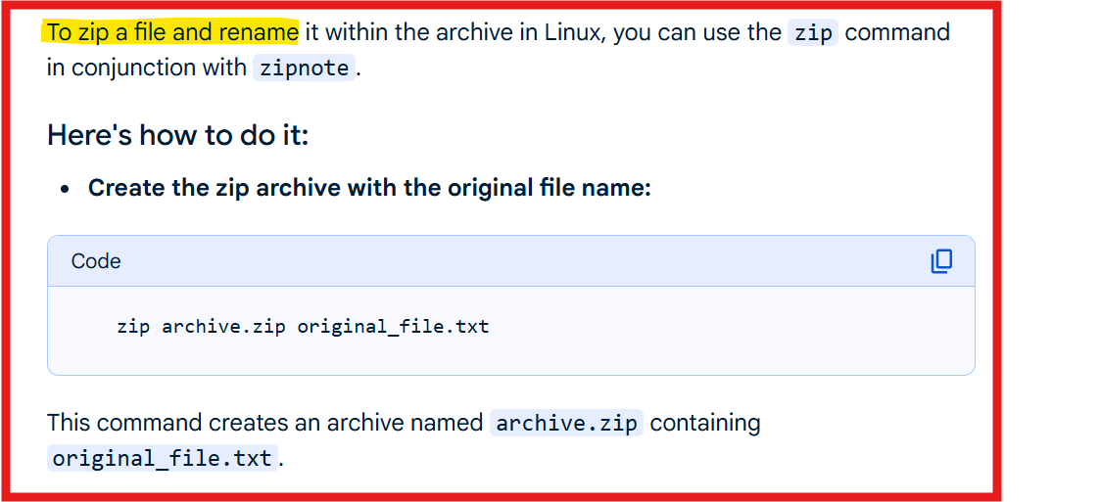

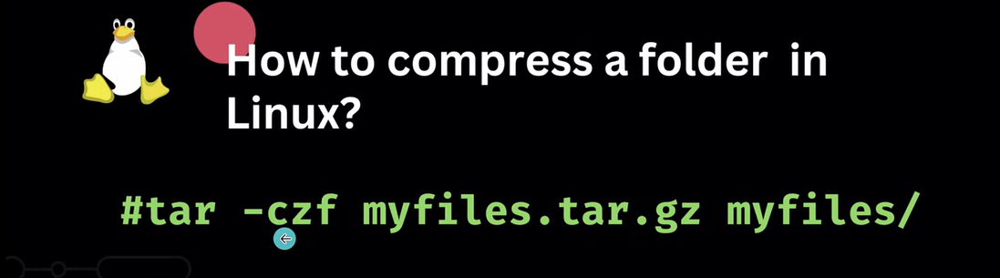

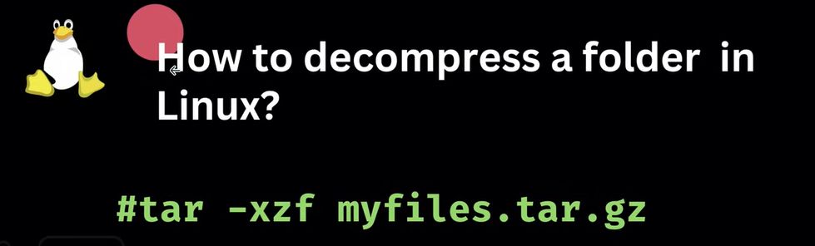

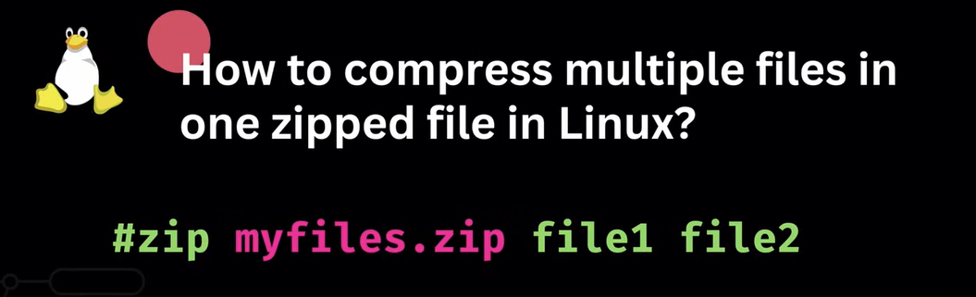



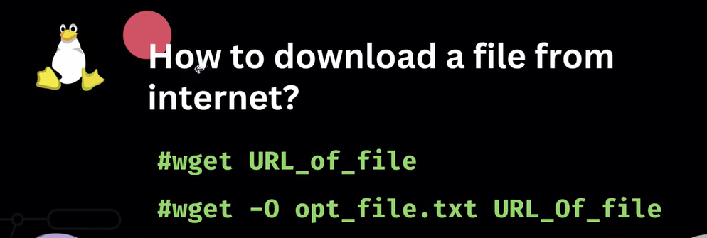

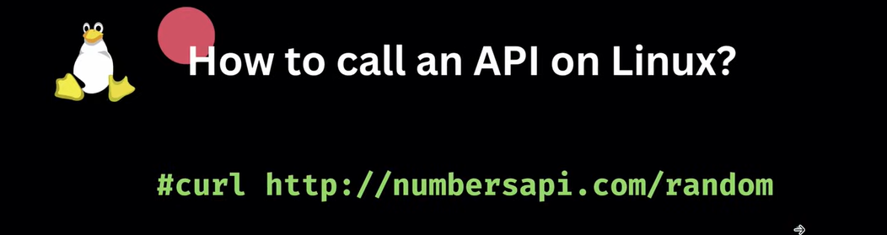



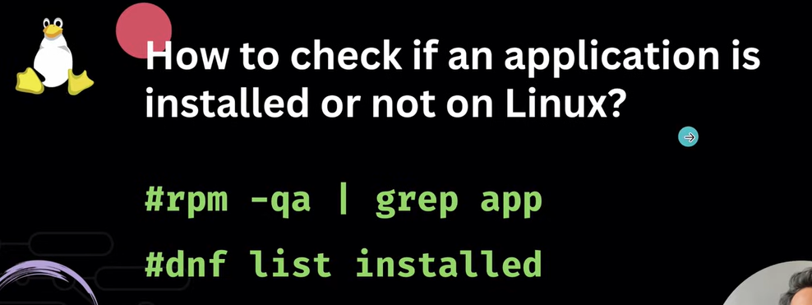



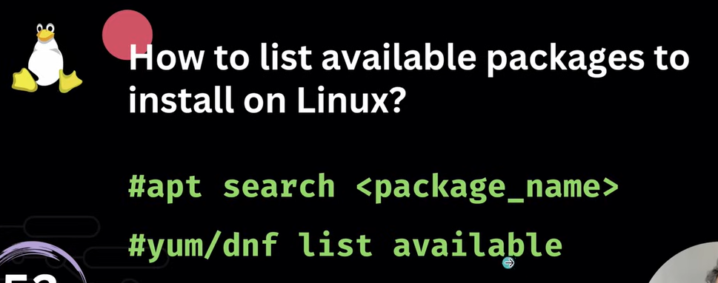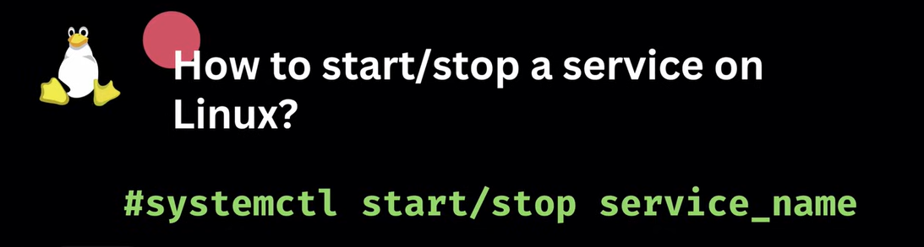

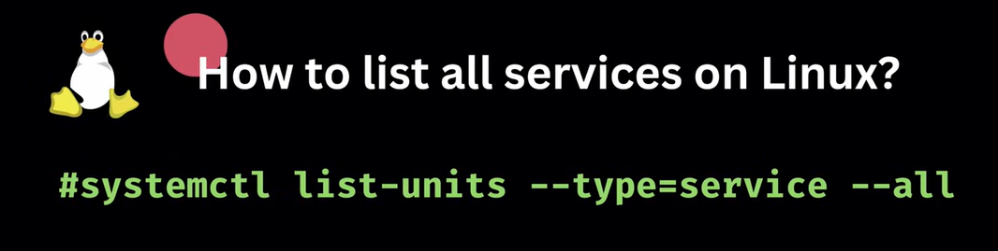

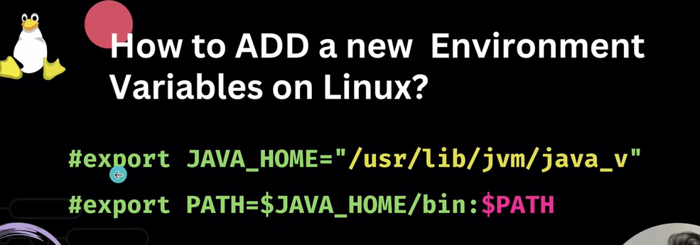

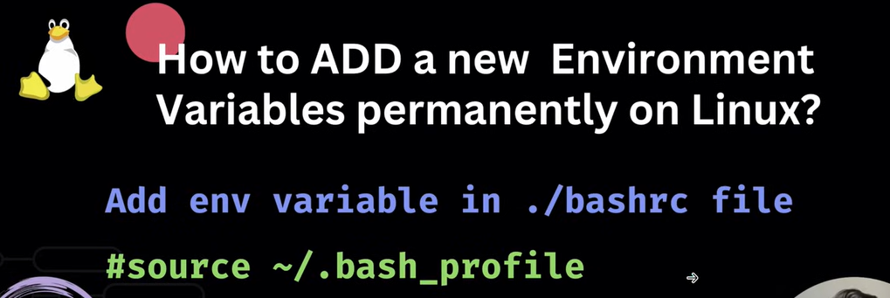

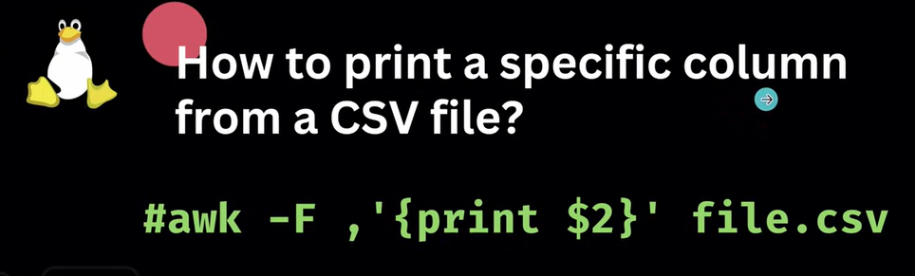**s**